**Practical No 8**

**Description:**

Selenium IDE has a huge list of commands using which it can automate and perform different actions like click, enter text, select, etc. on the UI elements in the web pages. Selenium IDE commands are shortly known or called as Selenese.

**Aim: To Study of Selenese Commands.**

**Theory:**

Selenium IDE has a huge list of commands using which it can automate and perform different actions like click, enter text, select, etc. on the UI elements in the web pages. Selenium IDE commands are shortly known or called as Selenese.

**Selenese Commands are as follows:**

**1) open**

Opens command opens a URL and waits for the page to load before proceeding. This accepts both relative and absolute URLs.

**Syntax:** open url

**Ex:** open / -opens home page of the site

open /about.php –opens the specified page

open https://phptravels.com

**2) type**

The purpose of type command in Selenium IDE, is to type any given text into the

text fields in the application. Can also be used to set the value of combo boxes, check boxes, etc. In these cases, value should be the value of the option selected, not the visible text.

**Syntax:** type locator, value

**Ex:** type name=q QAFox

**3) click command**

The purpose of click command in Selenium IDE, is to click on any UI element in the application.

**Syntax:** click locator

**4) click at command**

The purpose of click at command in Selenium IDE, is to click on any UI element at the given x & y coordinate position of the UI element. click at locator, coord string

The coordinates are relative to the target element (e.g., 0,0 is the top left corner of the element) and are mostly used to check effects that relay on them, for example the material ripple effect.

**arguments:**

locator - An element locator.

coord string - Specifies the x,y position (e.g., - 10,20) of the mouse event relative to the element found from a locator.

**5) double click command**

double click locator

Double clicks on an element (e.g., a link, button, checkbox, or radio

button).

**arguments**:

locator - An element locator.

**6) double click at**

double click at locator, coord string

Double clicks on a target element (e.g., a link, button, checkbox, or radio

button). The coordinates are relative to the target element (e.g., 0,0 is the

top left corner of the element) and are mostly used to check effects that

relay on them, for example the material ripple effect.

**arguments:**

locator - An element locator.

coord string - Specifies the x,y position (e.g., - 10,20) of the mouse event relative to the element found from a locator.

**7) set window size resolution**

The purpose of set window size command in Selenium IDE, is to resize the browser window.

Set the browser's window size, including the browser's interface.

**arguments:**

resolution - Specify a window resolution using Width x Height. (e.g., 1280x800).

**8) close**

Closes the current window. There is no need to close the initial window, IDE will re-use it; closing it may cause a performance penalty on the test.

**9) check**

The purpose of check command in Selenium IDE, is to select the radio button.

**10) uncheck**

The purpose of uncheck command in Selenium IDE, is to deselect the radio button.

**11) assert title**

The purpose of assert title command in Selenium IDE, is to check the title of the current page.

**k) assert value**

The purpose of assert value command in Selenium IDE, is to check that the value attribute value of the given UI element.

**12) assert text**

The purpose of assert text command in Selenium IDE, is to check the text on the UI element (i.e. The text between the HTML tags of the located UI element).

**Selenese Commands**

**Webpage Screenshot**

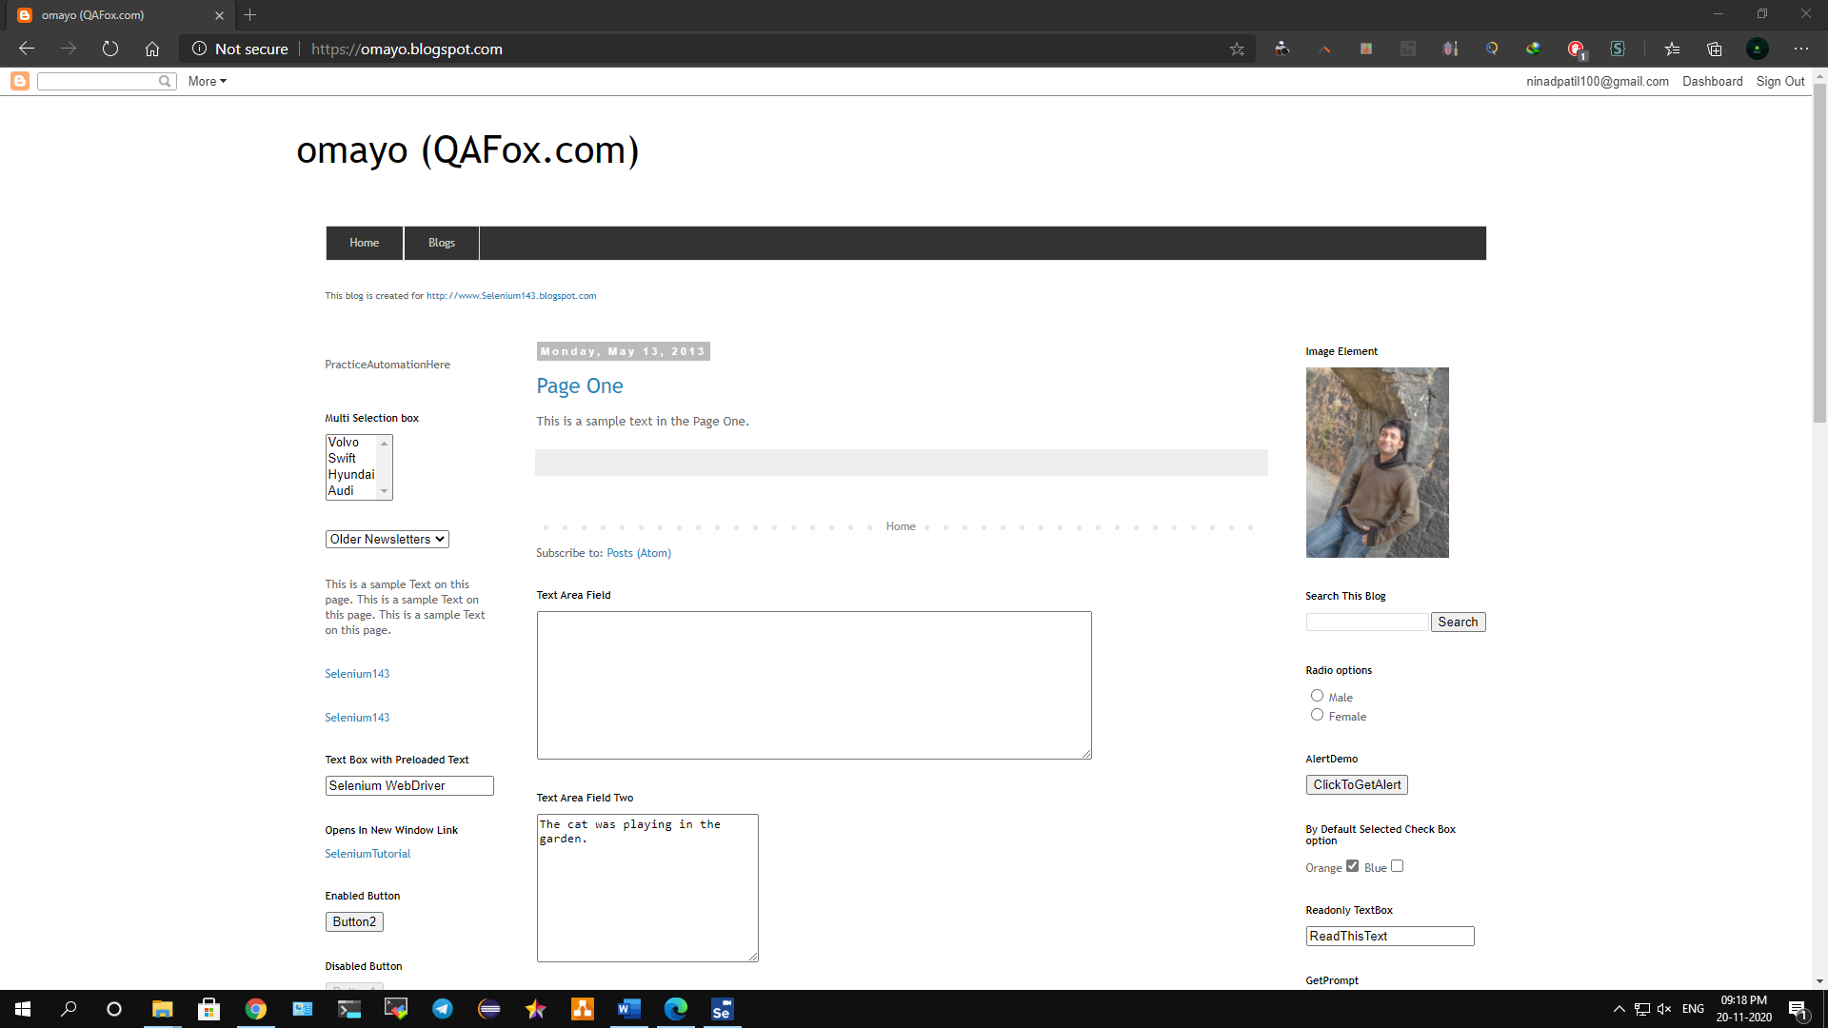

**Selenium IDE Screenshot**

**command**

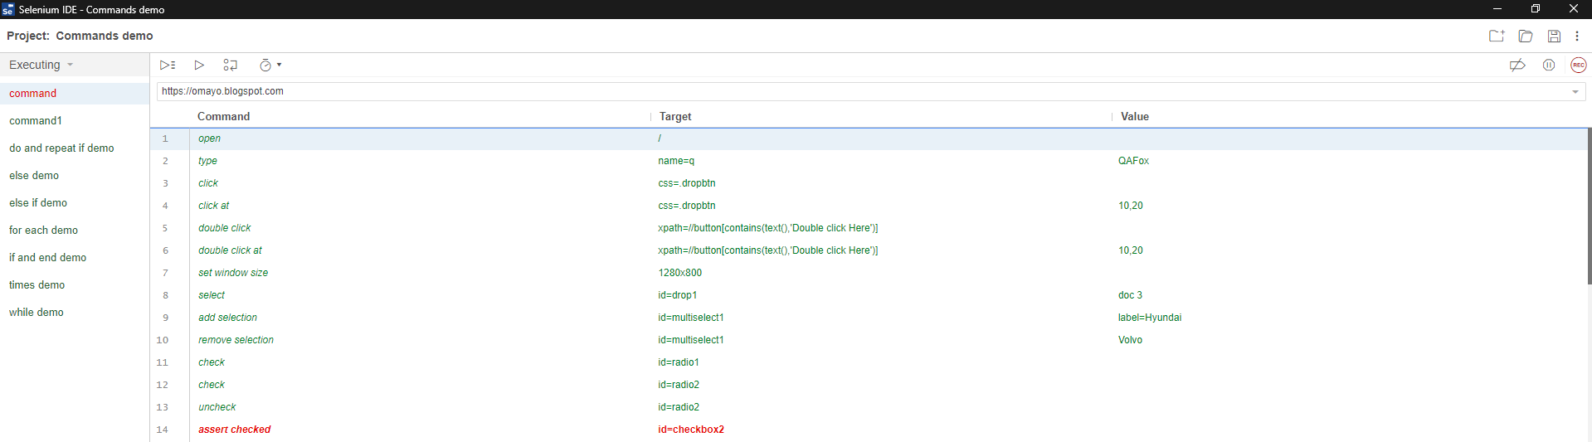

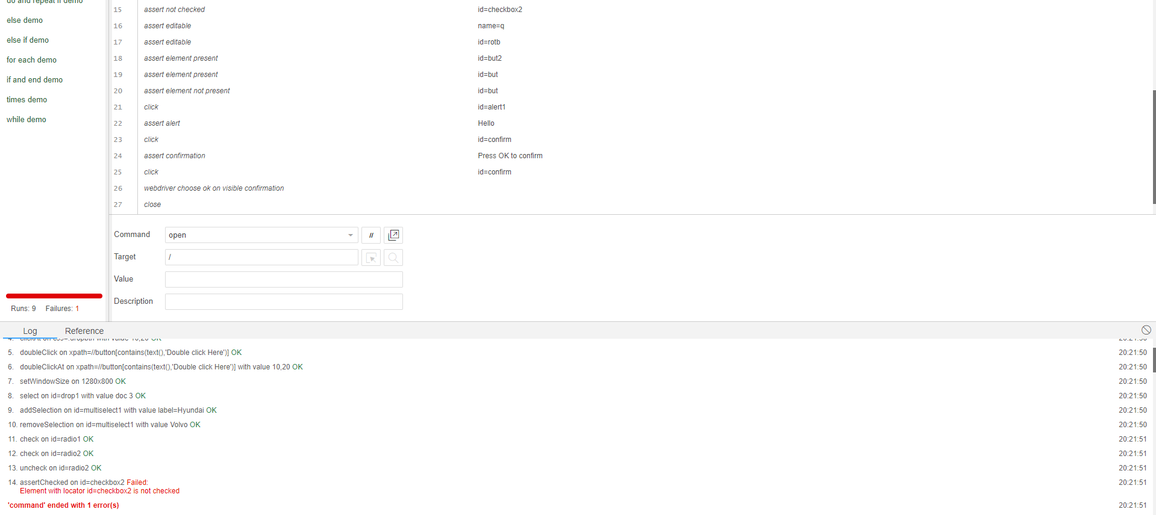

**command1**

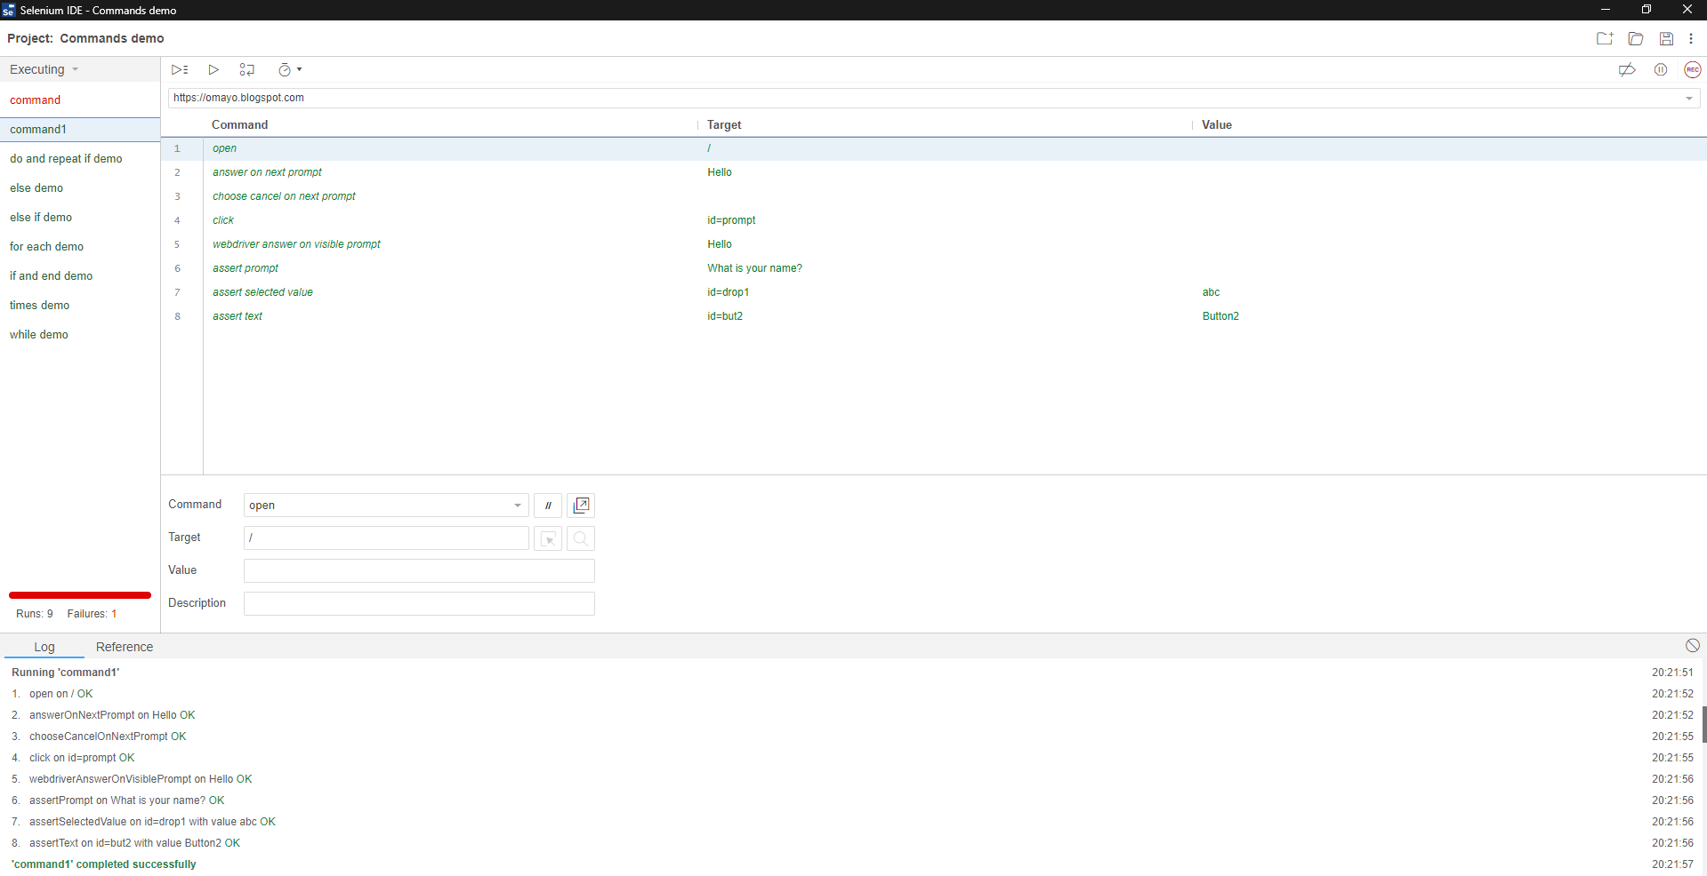

**do and repeat if**

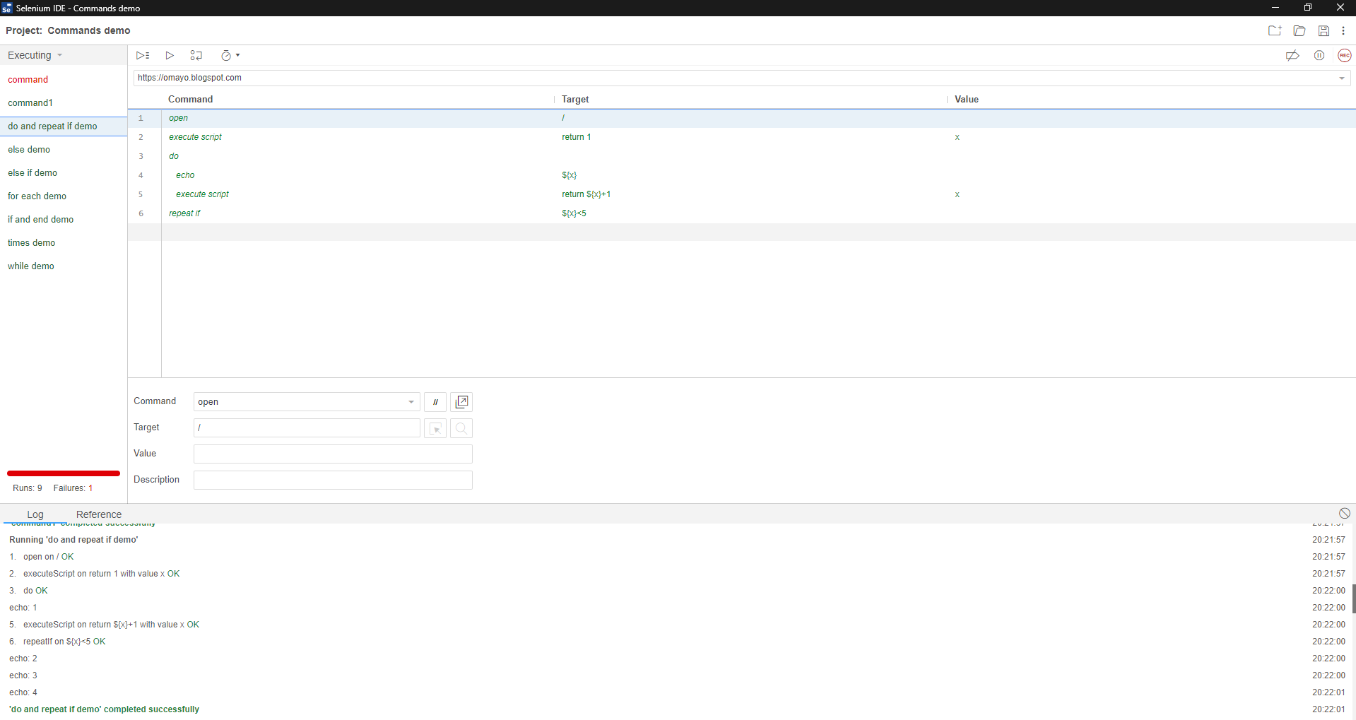

**else**

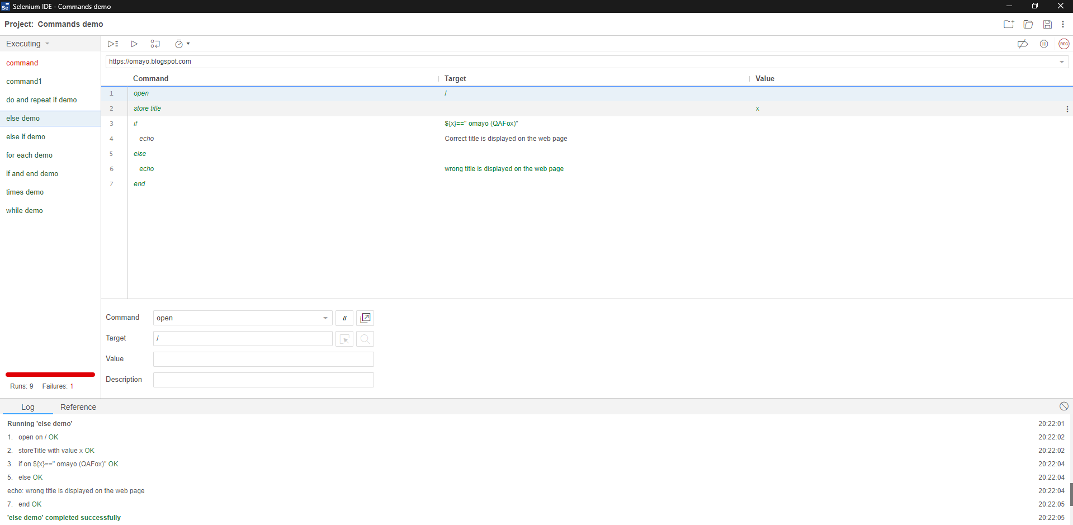

**else if**

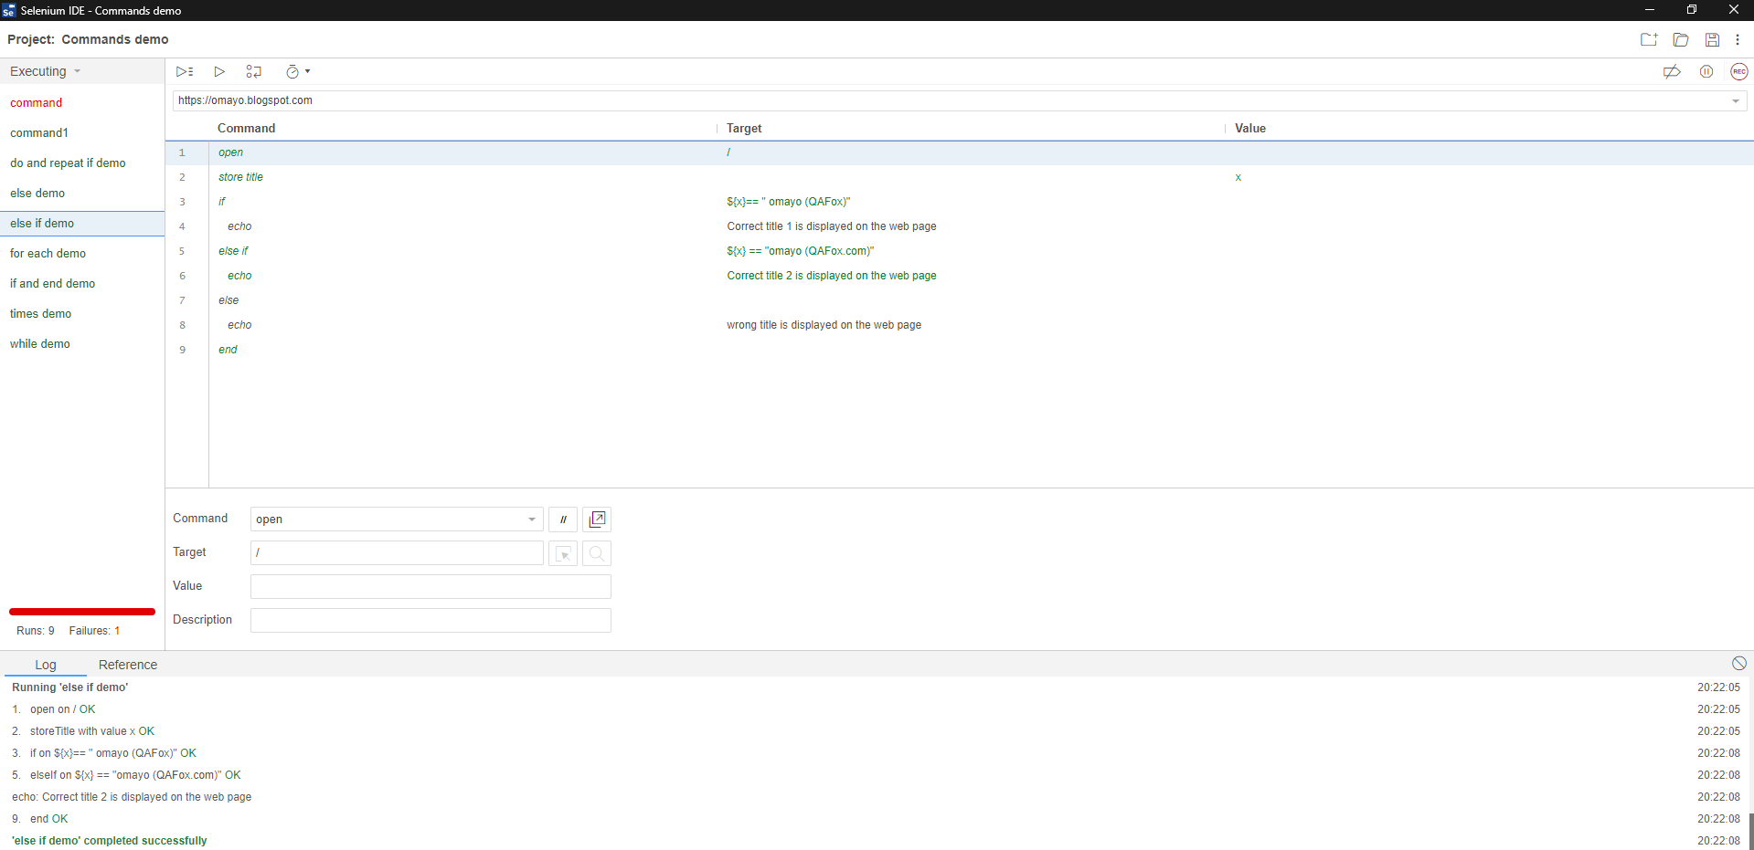

**for each**

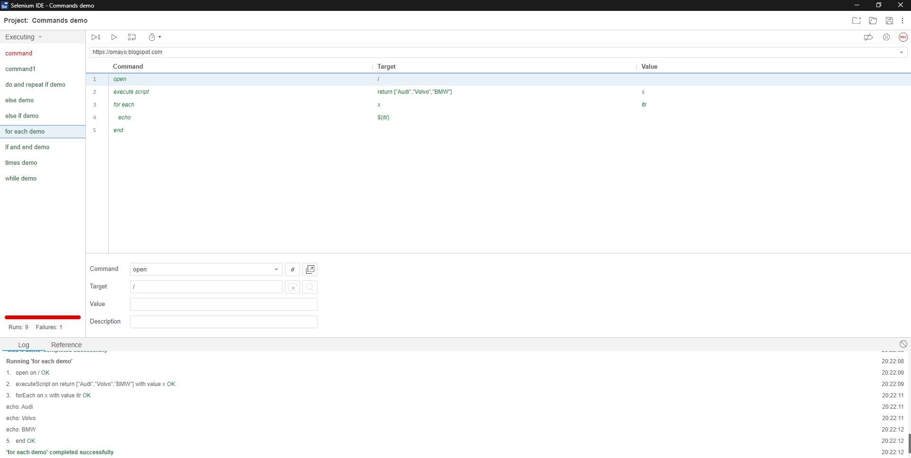

**If and end**

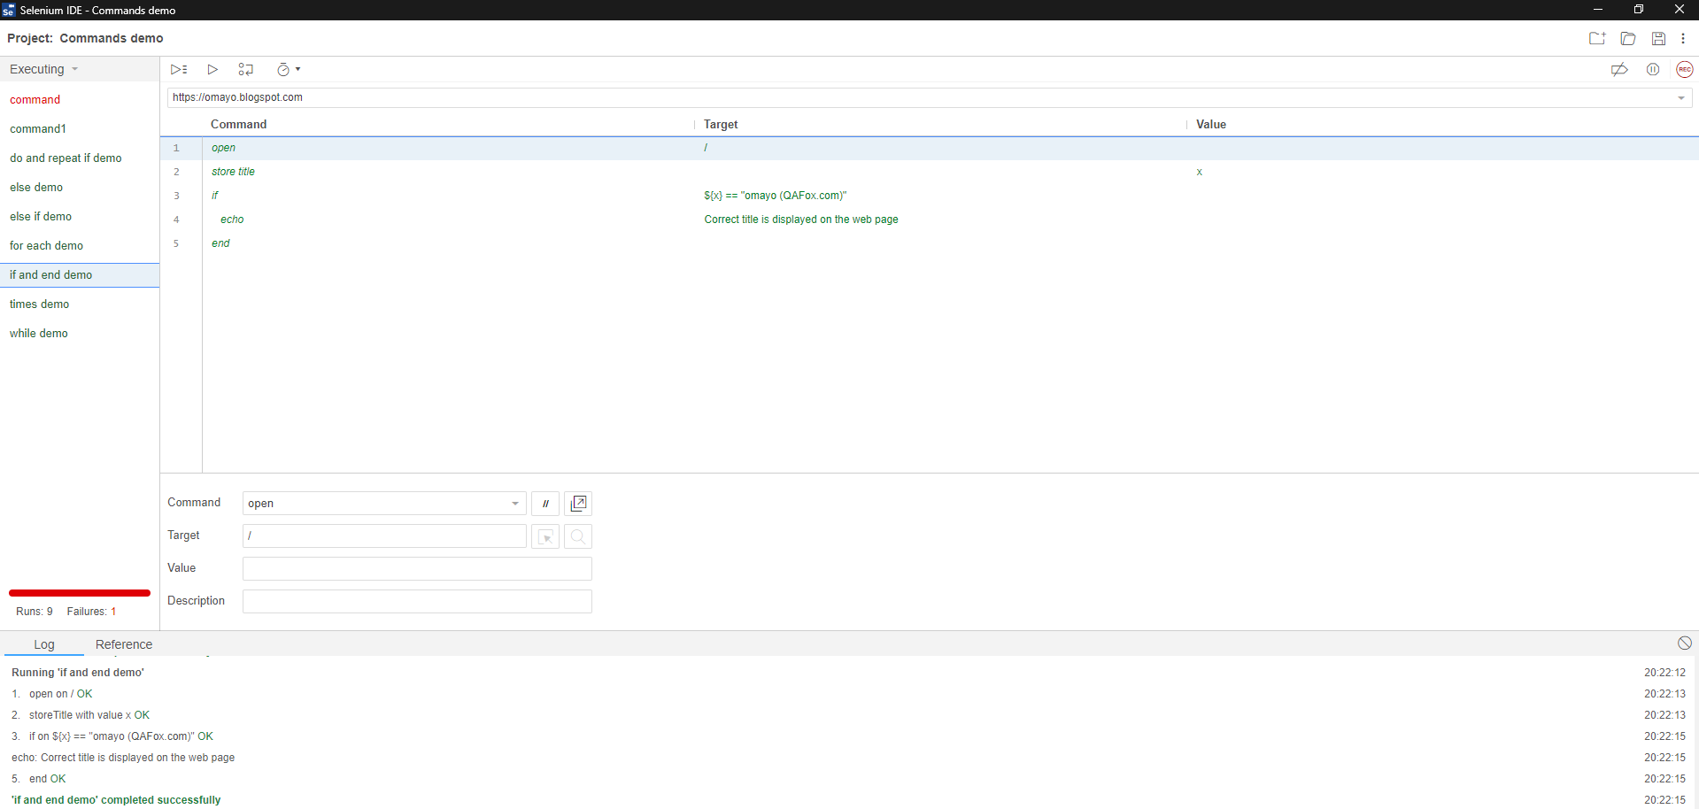

**times**

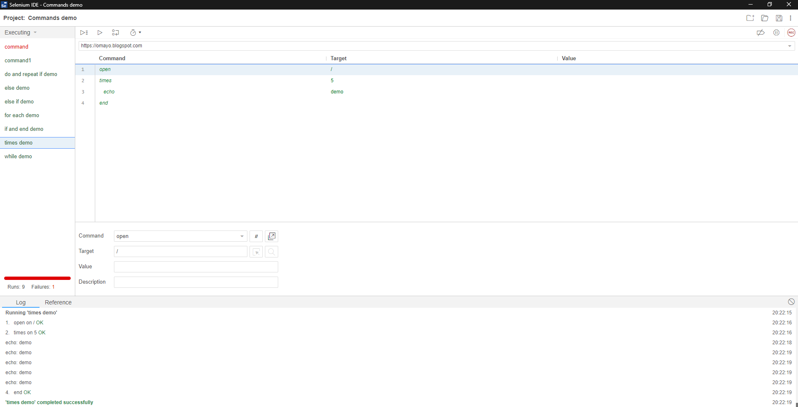

**while**

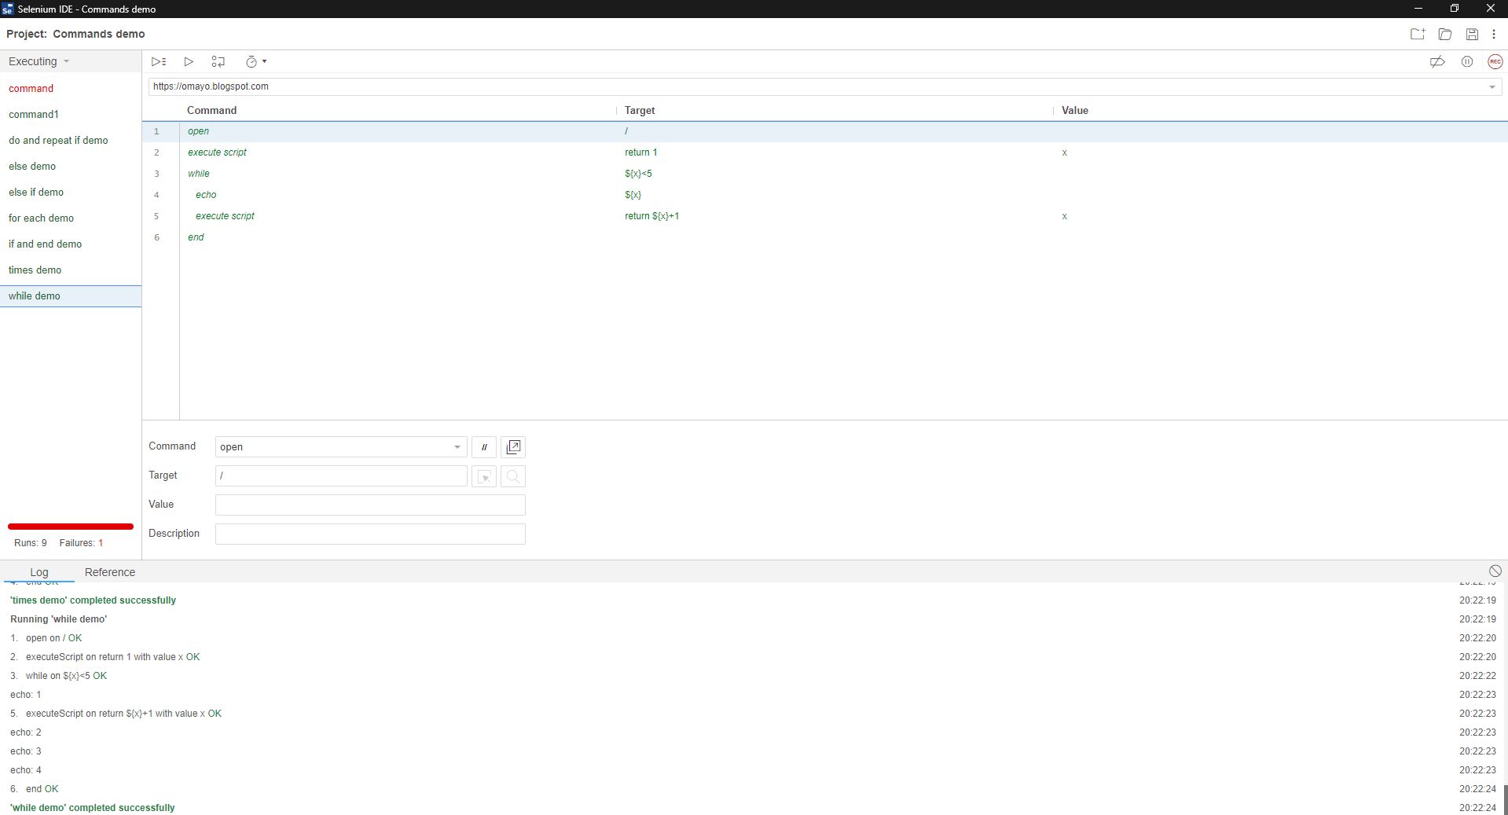

**Conclusion: We have studied the Selenese commands in details.**